Investigating metacognition and the transfer of academic writing skills in Technical higher education

Project draft
“…metacognitive knowledge of strategies and tasks, as well as self-knowledge, is linked to how students will learn and perform in the classroom. Students who know about the different kinds of strategies for learning, thinking, and problem solving will be more likely to use them. After all, if students do not know of a strategy, they will not be able to use it.” (Pintrich, 2002: 222)

Aim: This project combines different studies that aim to explore the concept of transfer in connection to writing in higher education, in a Swedish university. Using data from various student groups and types of courses, our goal is to understand what facilitates and hinders transfer and adaptation of knowledge to and through writing, and especially the role played by metacognition.
Background:
How do students learn to write at high levels of competence in higher education? Which pedagogical methods work best? The current project addresses these broad questions, and specifically the problem of transfer, an area of academic writing research that requires further inquiry. Transfer, as defined in genre theory and applied linguistics (Johns, 2011; Reiff & Barwashi, 2011), refers to “students’ ability to manipulate, even change (academic) genres to serve their own purposes” (Tardy, 2009, p. 282). Transfer demands writers’ development of agency: an awareness of how to adapt a variety of writing skills to authentic tasks and their own needs. Thus, transfer occurs when “learning in one context enhances (positive transfer) or undermines (negative transfer) a related performance in another context” (Perkins & Salomon, 1992: 6452), and positive transfer is therefore the assumed outcome of academic writing instruction in higher education, in more or less integrated/contextualized forms (Perin, 2011). This definition explains why transfer of academic writing skills—essential for successful academic performance—has been at the center of writing across the curriculum (WAC) efforts in the US for at least two decades. Even as recently as this year, complex, multiples-studies projects are being presented that explore and problematize how knowledge of writing flows and transfers across contexts and task complexities, in relation to aspects such as identity, language proficiency, content knowledge, and metacognitive knowledge (Anson & Moore, 2016). However, most of this work has been carried out in the US, and therefore in settings that are institutionally, culturally, and linguistically different from higher education settings in Europe.
This project seeks therefore to investigate the question of transfer of writing in a Swedish technical university, with a student population that is exposed to potentially different practices and expectations in terms of academic writing literacy. At the core of the project, there is the investigation of metacognition and its role in students’ ability to transfer and adapt writing strategies and skills. Metacognitive knowledge has been long indicated as essential in self-regulated learning and in students’ ability to transfer and adapt what they know to solve new problems and tackle new challenges successfully (Pintrich, 2002). The metacognitive component of transfer has been emphasized not only in the recent work mentioned above (Gorzelsky, Driscoll, Paszek, Jones & Hayes, 2016), but has also surfaced repeatedly in genre pedagogy, especially from a new Rhetoric perspective, but not only (see work by Beaufort, Reiff and Bawarshi, Artemeva, Johns). If we accept that the development of academic writing expertise requires the development of genre knowledge (Tardy, 2009), then metacognition has been indicated as enabling higher order transfer of skills, i.e. the transfer of critical thinking skills that allow students flexibly adapt their genre knowledge in a deliberate, agentive way. The connection between metacognition and transfer, and how genre analysis and genre pedagogy may foster this connection, has however not been studied extensively, and studies of how genre knowledge is learned and used are few (Cheng, 2008, 2011; Negretti, refs.). Questions that are still open, on the basis of work done so far (Negretti), include how metacognitive knowledge facilitates transfer to tasks that fall into the same genre but are more cognitively complex, from a new Bloom’s taxonomy perspective. Also, the lack of transfer from knowledge to performance needs investigation: although student may develop a good understanding of academic writing genres, it does not mean that they may be able to apply this knowledge in their own writing (Artemeva, 2010), and even advanced, graduate students may miscalibrate their evaluation of their own writing (Negretti, in press). Finally, what happens when students leave academic writing courses to tackle new tasks in content-based courses, or similar tasks but in a different situation with different conditions (Pintrich, 2002), for instance higher stakes (such as a bachelor essay or a research article submission)?

Project design: The project will rest on a platform of theories from different disciplines, necessary to understand transfer of learning phenomena in academic writing. From educational psychology, the framework of metacognition. From educational science, the revised Bloom’s taxonomy of cognitive complexity. From applied linguistics, and especially English for specific purposes (ESP) and genre analysis, the concept of genre knowledge and the research work on genre pedagogy.
The project will involve different studies, involving students at different levels and in different types of writing instruction situations.
- Two studies will address the connection between the development of genre knowledge through genre analysis (In an ESP approach), explicit instruction of metacognitive knowledge, and transfer to a similar but more cognitively complex task:
  - One of these studies will explore the situation in which students take a genre-based, academic writing course in concomitance to writing their bachelor essay in an engineering program, and will look both at the texts produced by the students—to identify similar rhetorical choices—as well as retrospective, stimulated-recalls interviews with the students, to identify which aspects of metacognitive knowledge were or were not transferred to the more complex and more “risky” writing task. In the writing course, students are guided in the analysis of disciplinary genres with different purposes, such as a BA essay, conference papers, and research articles. The students are then scaffolded in using their observations for self-evaluation and peer review.
Here there the challenge is connected to the fact that these students write collaboratively, and data collection and analysis become tangled.
  - The second study will have a similar design, but will involve Masters students in a similar engineering program (or possibly doctoral students), who thus have to face an individual writing task of higher cognitive complexity. Through interviews, the study will try to understand the transition from the evaluation of writing level (which is very much contextualized in this course, which has a peer review system similar to a conference), to the creation/evaluation aspects of thesis writing, and the role played by students’ metacognitive knowledge in this transition. The course involves scaffolded genre analysis of relevant texts (reading guide), and the development of a metacognitive scaffold in the form of a self-evaluation based on the students’ previous observations.
- A longitudinal study will follow undergraduate students across several courses in the same program, to map the connection between transfer (or lack thereof) and metacognitive knowledge of academic genres and writing skills from one course to the next, in connection with the development of content and procedural knowledge (in the Bloom’s taxonomy) specific to the disciplinary domain.
- A second longitudinal study setup follows two master level engineering programs over the two years. In the first of the two MSc programs, division staff have worked with faculty in a first-year writing course to help re-design a writing assignment with a view to the learning outcomes it needs to address in the course, but also with a view to the progression in the program towards project report writing and thesis writing in the second year. In the second year of that program, the division delivers a workshop series to facilitate project report writing in a project course. The next writing activity for this group of students is the master degree project, which we would like to study in this project. In the second of the two master program, division faculty have been involved in re-designing writing assignments and the teaching and learning activities scaffolding the writing assignments in two courses. One in the first year and one in the second year. We have also helped develop a series of workshops for master thesis writers on the program and for this project we would like to study the master degree project students and their sense of writing development and progression over the two year, with a focus on how they may have developed metacognitive knowledge of writing, especially conditional knowledge (an understanding of the contextual and social conditions tied to a specific task), and how they use this knowledge in writing their thesis.
- Another potential study will investigate the benefits of scaffolding metacognitive knowledge of argumentative writing strategies in a content-integrated writing course (design engineering), from a perspective of formative assessment and the development of accuracy in students’ evaluation of their writing. In this content-integrated course, students are asked to write an argumentative text about their design. Each session presents writing techniques; students are then asked to apply them to brief homework assignments which gradually build up the final assignment. Each “homework” assignment is peer and self-evaluated the following session using the course assessment criteria. At the end of the course, together with the final assignments students submit a self-assessment with comments. Two teachers then assess the final independently, and the idea is to see if the students’ assessment correlate to the teachers, both quantitatively (inter-rater reliability) and qualitatively. The study can provide an insight on writing quality connects to metacognitive calibration in authentic writing situations, and in general illuminate potential approaches to self-regulated strategy instruction of writing in higher education.
- Finally, I would also like to do a loose replication of Artemeva (2010), and look into genre knowledge vs. genre performance, perhaps looking the difference between students who have taken genre-based courses and students who have not, once they then enroll in a content course requiring writing. In her study, she asked first-year students to label different texts that belonged to different genres but concerned the same topic, and showed that most students could correctly recognize different genres (including academic writing). When asked to produce a short academic text, however, only a small percentage of the students were able to produce a text on the topic that was academic. This disconnect between knowledge and performance is problematic in terms of the underlying assumptions of genre-based pedagogy, and it has been suggested that one of the issues is students’ lack of metacognitive knowledge about how previous writing experiences and competences can be used for new tasks.
Therefore, in this study (the specific course or group of students is not established yet), I would like to do some sort of replication, looking also at their previous experiences of writing in HE: do students who have taken genre-based courses transfer to performance more easily? Why?
Institutional description: Chalmers University of Technology is high-ranked higher education institution in Sweden, comprising theoretical and applied programs at the undergraduate, Masters and research (Doctoral) level in science, engineering and technology. Within this university, the Division of Language and Communication, where I work as a senior lecturer (assistant professor) benefits from a unique position, being involved in teaching interventions in every department, and at every level of education (see Gustafsson, Eriksson & Karlsson, 2016, for an in-depth description). In this sense, we have the opportunities to access a student population, and learning contexts, that are unique. For a study of transfer, such a situation is the ultimate research ideal: similar efforts in other institutions have required the involvement of different departments, while we can flexibly steer the project within our unit, thanks to our already established presence within departments, programs and courses. From a research point of view, this situation also offer another advantage: in our unit, language and communication activities have long been developed either in integration with content courses, or on the basis of a genre pedagogy/disciplinary literacy approach providing a unique opportunity for an ecologically valid study of learning (Van Lier, 2010).
The courses potentially in focus for this project are primarily in engineering programs. These courses enroll from 40 to 80 students (MA and BA respectively). Some of the courses occur in parallel to discipline content courses, whereas other interventions have a more or less strong integrated component, i.e. the tasks, outcomes and examination are the same, and are graded by both writing and content teachers, or by content teachers (MA course).

Glossary

- Metacognition: see below
- Calibration: a person’s ability to metacognitively evaluate their performance in an accurate way. Requires conditional metacognitive knowledge: the understanding of the conditions in which a specific task/problem is carried out (expectations, purpose, criteria for assessment etc.)
- Genres: communicative practices for specific purposes and audiences, characterized by conventions and values that are recognized by the discourse communities that own them.
- Genre analysis: the analysis of (typically) academic texts to identify the strategies typically employed by authors to convey their ideas and persuade their readers (i.e. rhetorical moves), based on audience expectations and recognized purposes of the texts.
- Genre pedagogy: the approach to writing instruction that adopts genre analysis and places emphasis on helping students understand the connections between audience, purpose, and formal/rhetorical features of academic texts. In ESP (English for Specific Puposes), much focus is placed on disciplinary uses of language, text structures, and the analysis of rhetorical moves.
- Rhetorical moves: Sections of a text that have a specific strategic function, and thereby present content through linguistic and stylistic choices that are more or less genre-conventionalized.
- Rhetorical consciousness: a writer’s understanding of the impact of specific rhetorical choices in relation of audience expectations, and thus their deliberate control of these choices to achieve their communicative goals.
- Genre acquisition: similar to rhetorical consciousness, but tied to a specific genre and discourse community.
- Genre performance: the ability to actually perform the genre, i.e. apply genre awareness/knowledge to produce texts that are rhetorically effective from the point of view of their purpose and target audience

Digest of theories.
Metacognition and metacognitive knowledge.
Often connected to self-regulation (SR) and self-regulated learning, SRL), metacognition is defined as the knowledge about and regulation of one’s knowledge and thinking (Flavell, 1979; Brown, 1978). It is typically distinguished into two components: metacognitive knowledge (or awareness) and metacognitive skills (or strategies) (Pintrich, 2002; Schraw, 2001). Metacognitive knowledge has been characterized as more stable and conscious (hence at times called “awareness”, Schraw & Dennison, 1994): it includes learners’ knowledge of strategies and how to use them for different tasks, the learning process, and themselves as learners (Flavell, 1979). A further distinction regards learners’ ability to understand what they know (declarative knowledge), how to apply this knowledge (procedural) and why some knowledge or strategies may be more relevant to certain situations (conditional) (Schraw & Dennison, 1994). Metacognitive strategies are online skills that learners (consciously and unconsciously) employ during problem solving, and therefore include planning, monitoring and evaluating (Schraw, 2001).
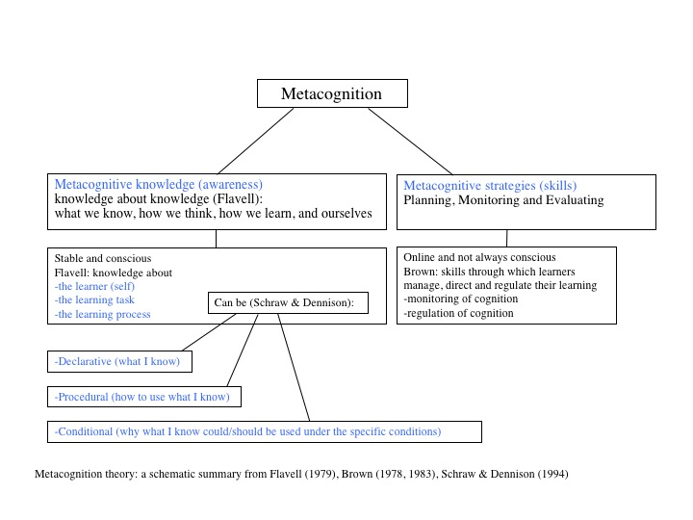
Metacognition: a visual summary (from Negretti & McGrath, forthcoming)
Genre Analysis and Genre knowledge
Genre knowledge, as defined by Tardy (2009) spans different aspects of learning, beyond textual/formal conventions (p. 20); formal knowledge refers to knowledge of structural, textual and linguistic features of genre, i.e. the “discourse” in a strictly linguistic point of view; process knowledge refers to an understanding of how texts are produced, including individual writing practices; rhetorical knowledge refers to the social, communicative and strategic aspects of academic writing, including authors’ intentions, stance, identity, and audience expectations. Genre analysis/pedagogy from an ESP perspective was launched by Swales (1990), who stressed the importance of helping L2 writers develop rhetorical consciousness. Thus, the development of academic writing skills in FL/L2 writers has been extensively equated to the development of genre knowledge/awareness: learners’ ‘‘rhetorical flexibility necessary for adapting their socio-cognitive genre knowledge to ever-evolving contexts’’ (Johns, 2008, p. 238). In this view, the concept of genre is more than text type, but rather a conventionalized way of communicating in specific contexts/communities.
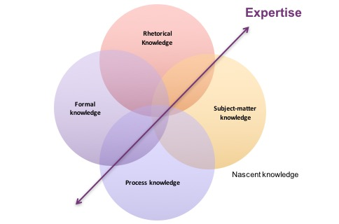
Tardy’s (2009) framework of genre knowledge
Bloom’s taxonomy of cognitive complexity
Bloom’s taxonomy (1956) was intended as a framework of educational objectives, rather than an instrument to measure learning outcomes. In this project, the revised taxonomy (Anderson, Krathwohl et. al, 2001; cf. Krathwohl, 2002) will be used as a heuristic to conceptualize our studies and analyse qualitative data. The revised taxonomy has two dimensions: a knowledge dimension, presenting different knowledge “types” (overlaps with the genre knowledge framework can be easily detected), and a cognitive process dimension, which presents increasing levels of cognitive complexity. This framework, as used in this study, allows to explore transfer at different points of intersection of these two dimensions. Studies on metacognition and adaptation to cognitive complexity, for instance, have pointed out that at increasing levels of complexity, adaptation strategies are not always successful (Pieschl et al., 2012), possibly because of the complexity of the contextual conditions. A similar situation can be envisioned for academic writing, which often requires students to work at the evaluative/creative level.
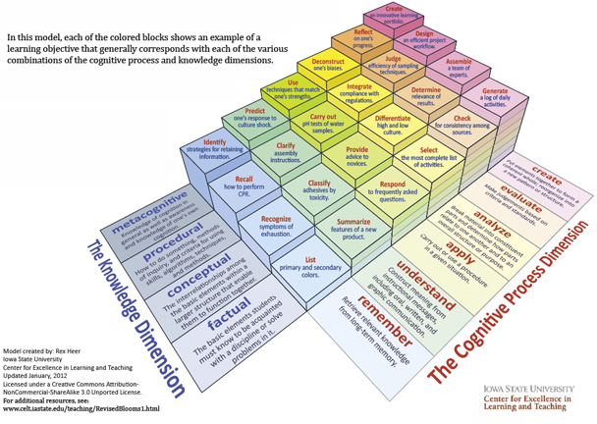

References
Anderson, L.W. (Ed.), Krathwohl, D.R. (Ed.), Airasian, P.W., Cruikshank, K.A., Mayer, R.E., Pintrich, P.R., Raths, J., & Wittrock, M.C. (2001). A taxonomy for learning, teaching, and assessing: A revision of Bloom's Taxonomy of Educational Objectives (Complete edition). New York: Longman
Anson, C. & Moore, J. (Eds.) (2016). Critical transitions: Writing and the question of transfer. The WAC Clearinghouse, available online in pre-rint format: http://wac.colostate.edu/books/ansonmoore/
Artemeva, N. & Fox, J. (2010). Awareness vs. production: Probing students’ antecedent genre knowledge. Journal of Business and Technical Communication, 24,476-515. doi:10.1177/1050651910371302
Bloom, B.S. (Ed.), Engelhart, M.D., Furst, E.J., Hill, W.H., & Krathwohl, D.R. (1956). Taxonomy of educational objectives: The classification of educational goals. Handbook 1: Cognitive domain. New York: David McKay
Clark, I. (2016). Genre, Identity, and the Brain: Insights from Neuropsychology. The Journal of General Education, 65(1), 1-19.
Cheng, A. (2008). Analyzing genre exemplars in preparation for writing: The case of an L2 graduate student in the ESP genre-based instructional framework of academic literacy. Applied linguistics, 29(1), 50-71.
Cheng, A. (2011). Language features as the pathways to genre: Students’ attention to non-prototypical features and its implications. Journal of Second Language Writing, 20(1), 69-82.
Devitt, A. J. (2015). Genre performances: John Swales' Genre Analysis and rhetorical-linguistic genre studies. Journal of English for Academic Purposes, 19, 44-51.
Gustafsson, M., Eriksson, A., & Karlsson, A. (2016). Facilitating writing in the tension between the quasi-generic and the multidisciplinary: Chalmers University of Technology. Supporting graduate student writers.
Hyland, K. (2007). Genre pedagogy: Language, literacy and L2 writing instruction. Journal of second language writing, 16(3), 148-164.
Hyland, K. (2016). Academic publishing and the myth of linguistic injustice. Journal of Second Language Writing, 31, 58-69.
Johns, A. M. (2008). Genre awareness for the novice academic student: An ongoing quest. Language Teaching, 41, 237–252.
Johns, A. M. (2011). The future of genre in L2 writing: Fundamental, but contested, instructional decisions. Journal of Second Language Writing, 20(1), 56-68.
Krathwohl, D. R. (2002). A revision of Bloom's taxonomy: An overview. Theory into practice, 41(4), 212-218.
Kuteeva, M., & Negretti, R. (2016). Graduate students' genre knowledge and perceived disciplinary practices: Creating a research space across disciplines. English for Specific Purposes, 41, 36-49.
Negretti, R. (2012). Metacognition in student academic writing: A longitudinal study of metacognitive awareness and its relation to task perception and evaluation of performance. Written Communication, 29(2), 142-179.
Negretti, R. (in press). Calibrating genre: Metacognitive judgments and rhetorical effectiveness in academic writing by L2 graduate students. Applied Linguistics http://dx.doi.org/10.1093/applin/amv051
Negretti, R. and Kuteeva, M. (2011). Fostering metacognitive genre awareness in L2 academic reading and writing: A case study of pre-service English teachers. Journal of Second Language Writing, 20, 95–110.
Perkins, D. N., & Salomon, G. (1992). Transfer of learning. International encyclopedia of education, 2, 6452-6457.
Pieschl, S., Stahl, E., Murray, T., & Bromme, R. (2012). Is adaptation to task complexity really beneficial for performance?. Learning and Instruction, 22(4), 281-289.
Reiff, M. J., & Bawarshi, A. (2011). Tracing discursive resources: How students use prior genre knowledge to negotiate new writing contexts in first-year composition. Written Communication, 28(3), 312-337.
Swales, J. (1990). Genre analysis: English in academic and research settings. Cambridge University Press.
Swales, J. M. (2011). Coda: Reflections on the future of genre and L2 writing. Journal of Second Language Writing, 20(1), 83-85.
Tardy, C. M. (2009). Building genre knowledge.
Van Lier, L. (2010). “Ecological-semiotic perspectives on educational linguistics”. In The handbook of educational linguistics.

