Decolonizing the Critical Thinking Classroom Through Oral Histories of Moroccan Women and Cultural Heritage
Awatif Boudihaj
This project is part of a larger initiative in which students engage with decolonial approaches to critical thinking. Students explore the concepts of intangible cultural heritage (ICH) and digital linguistics. They critically examine cultural and language heritage initiatives that shape the efforts to safeguard indigenous and local languages and cultural heritage in the contemporary world. The author received training at the Oral History in the Liberal Arts (OHLA) summer institute in 2023, where the training focused on digital technologies as tools for preserving cultural heritage and languages. Using the oral histories of Moroccan women as a central lens for analysis, students engage with theoretical concepts, practical applications, and ethical considerations related to the digitization of cultural and linguistic expressions.
Before the interviews, students participate in a variety of learning and preparation activities, including an introduction to critical thinking concepts and the theoretical foundations of Intangible Cultural Heritage (ICH), with a focus on UNESCO's frameworks for ICH preservation. Students conduct background research on proverbs, music, and cultural artifacts as carriers of cultural heritage. These discussions help students understand the significance of these cultural elements and identify problematic attitudes and power dynamics reflected in music or proverbs.
Next, students learn the oral history technique, with exposure to key sensitive social-emotional issues involved in interviewing elders who have experienced traumatic events. The focus then shifts to using digital technologies for documentation and preservation. This phase includes teacher-directed readings, targeted lectures, and training in data collection methods, i.e., interviews, with a strong emphasis on ethical considerations. Throughout the project, students receive ongoing feedback and troubleshooting support. The final stage of the project showcases students’ digital work, culminating in reflections on the research process and the broader impact of negative representations of women in the Moroccan history/society. Students also explore how women have challenged these perceptions through critical conscientization.
Students gain a deeper understanding of how intercultural dialogue can help deconstruct stereotypes and foster sensitivity and creativity in addressing shared challenges. They discuss common stereotypes about women found in proverbs/language and engage in conversations that uncover the realities behind these misconceptions. Students also address emerging prejudices, highlight shared challenges, and propose solutions. By opening the floor to discussions on stereotypes, sensitivities, and shared challenges, this project promotes education, understanding, and collaboration while emphasizing the importance of intercultural awareness.
The Impact of Interviews on Student Growth and Understanding
Students often experience anxiety when approaching interviews, especially when the subject involves deep personal or traumatic experiences. Finding a woman willing to be recorded can be especially challenging, particularly when discussing sensitive topics such as women’s hardships or efforts to overcome societal challenges. Many Moroccan women may feel uncomfortable sharing their personal struggles or may hesitate to have their stories documented digitally. Additionally, cultural and generational gaps can make it difficult for students to establish trust and rapport with potential interviewees.
For women from the Middle Atlas region, cultural barriers are even more pronounced. Many women from this area are traditionally reserved and may be particularly reluctant to appear on camera or publicly share their experiences. Their hesitation often stems from deep-rooted cultural norms that emphasize privacy, modesty, and the expectation that personal or family hardships should remain private. As a result, students may struggle to find interviewees who are willing to engage in recorded discussions about their struggles, particularly when it comes to topics like entrepreneurship and economic independence. Initiating conversations and keeping the interviewee engaged can also be difficult, especially if women have never shared their experiences publicly before. The added pressure of being recorded, knowing their work may reach a wider audience, can make the process even more intimidating.
Despite these challenges, students often find that interviewees are willing to share their stories when approached with respect, patience, and genuine interest. By actively listening and demonstrating cultural sensitivity, students create a space where women feel comfortable opening up about their experiences. This process not only deepens students’ understanding of critical thinking and oral histories but also strengthens their ability to navigate complex social interactions with empathy and professionalism. One student reflects on her experience:
"By conducting an interview with Mrs. Najia, a member of my community, I was able to step out of my comfort zone and experience something completely new. I had to approach someone I wasn’t very familiar with, which challenged my confidence and communication skills. The interviewee shared her experience of receiving an education during a time when women’s education wasn’t widely accepted in Moroccan society. As I listened to her, I sympathized with women who didn’t have the same opportunity to be educated as Mrs. Najia, and I felt incredibly grateful for the opportunity I’ve had."
The success of these interviews often lies in the intergenerational connection established between students and their interviewees. One student reflected on the experience of interviewing his grandmother:
"This interaction deepened my empathy and opened my eyes to the resilience and strength within my own community. The grandmother’s account highlighted the interconnectedness of personal stories and global movements for justice and equality. Hearing her firsthand experience of fighting against oppression during Morocco's colonial era made these historical events feel more tangible and relatable. When she told me that it was common for minor girls to be forced into marriage, it shocked me. The way she described it made it seem like it was a bad but accepted part of life. I can’t imagine the impact of living in such a reality. This project allowed me to connect directly with someone who lived through significant events and reminded me of the importance of preserving oral history as a bridge between personal experiences and community history."
The broad impact of the oral history project is evident in dialogues between students and women in a local cooperative in the Middle Atlas. Students traveled to the village of Zawyat Si Abdessalam to conduct collaborative interviews with women who had just started a small business:
"When you interview someone from a different background in society, you gain a new understanding of diversity and the global issues that may arise at the local level. This project provides a unique connection to real-world problems. 'In this region, for a woman to start working or own a business is considered strange, so there are mixed opinions about it. After opening this store, we started hearing a lot of talk about the concept. On one hand, some men and even women criticize our work, but this does not stop us from continuing. On the other hand, we receive compliments that encourage us to keep going because, at the end of the day, we don’t really have a choice.'"
This conversation demonstrates the resilience of women working in Morocco’s working-class neighborhoods, where overcoming criticism based on deeply entrenched collective mindsets is a necessary barrier. Some initiatives are underway to empower Moroccan women and integrate them into the nation’s development efforts, promoting gender equality.
Digital Project Description
As part of the project, students will record a video or audio (in person or virtually) with someone from an older generation, discussing their experiences and perceptions. Students are trained to operate cameras or use their mobile phones during the interview, with an emphasis on the person’s narrative rather than the technology per se. The final stage of the project involves publishing the interview to the Aviary platform, where students post their work, enter metadata, and index and segment their interview.
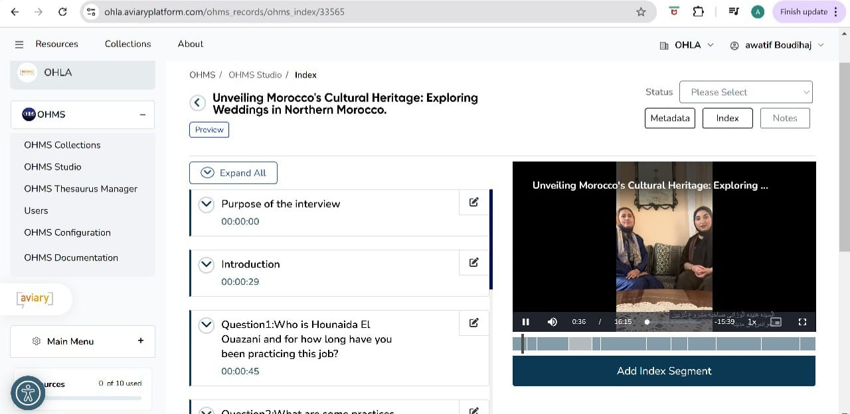
https://www.youtube.com/watch?v=aqQFbCdTkc0&ab_channel=MNeimi

Cultural Statement
This project provides students with a unique opportunity to explore cultural richness through the voices and lived experiences of Moroccan women while deconstructing existing social biases and stereotypes. By prioritizing oral histories, this project aim to decenter dominant narratives and create an inclusive learning environment where diverse epistemologies are recognized and respected.

